Omkar Thakur

CS 550

Final Project Proposal

Earths view from the moon. The placement of the eye position will be on the moon and it can see earth partially. The earth’s sphere will be in partial light and partial darkness. A rocket will be also seen coming from the earth to moon. Maximum amount of celestial bodies with some planets will also be shown in

the project.

.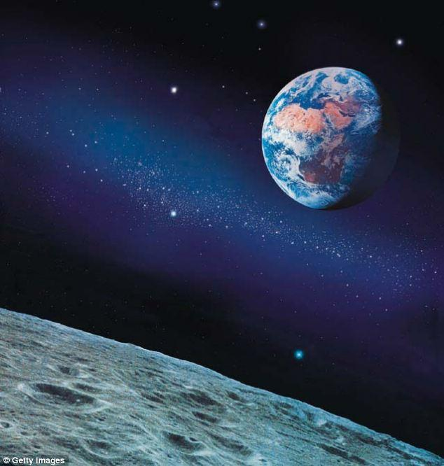

Appropriate lightning will also be applied on the celestial bodies as well as the moon and the earth. A rocket will also be shown travelling from earth to outer space. A slight flame may be seen on the rocket. The rocket will also transition from a surface having light to a dark surface. Some small satellites may be seen. This is because, this project is based more on creativity than reality. Therefore, the size of the rocket will be more than the relative size of the rocket. This is because it should be seen by eyes.

The planets and the celestial bodies may not move. But planet earth might show some movement. This is for the project to be more challenging. I also have an idea to show some amount of fog in project around planet earth. But this may or may not be fulfilled. Some of the stars will also be shown. Attenuation of light formed with many stars may or may not be seen. But I can give a try for that